Special Educational Needs and Disabilities (SEND) Information Report
Grove Park Primary School



Inclusion Team
SEND Governor:
Zoe Silvester

SENCO:
Mrs Amanda Harling
Contact No. 01795 477417
Amanda.harling@ba-mat.org.uk

Approved by: | Trust Board | Date:
Last reviewed on: November 2025
Next review due by: November 2026

Contents
Contents 2
1. What types of SEND does the school provide for? 4
2. Which staff will support my child, and what are their key responsibilities? 5
3. What should I do if I think my child has SEND? 7
4. What happens if the school identifies a need? 8
5. How will the school measure my child’s progress? 10
6. How will I be involved in decisions made about my child’s education? 12
7. How will my child be involved in decisions made about their education? 12
8. How will the school adapt its teaching for my child? 13
9. How will the school evaluate whether the support in place is helping my child? 14
10. How will the school ensure my child has appropriate resources? 14
11. How will the school make sure my child is included in activities alongside pupils who don’t have SEND? 15
12. How does the school make sure the admissions process is fair for pupils with SEN or a disability? 15
13. How does the school support pupils with disabilities? 16
14. How will the school support my child’s mental health and emotional and social development? 16
15. What support is in place for looked-after and previously looked-after children with SEND? 17
16. What support will be available for my child as they transition between classes or settings or in preparing for adulthood? 17
17. What support is available for me and my family? 18
18. What should I do if I have a complaint about my child’s SEND support? 19
19. Supporting documents 20
20. Glossary 20

Dear parents and carers,
The aim of this Information Report is to explain how we implement our SEND policy. In other words, we want to show you how SEND support works in our school.
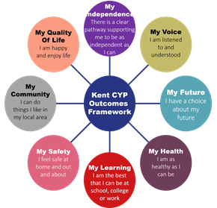
As educational professionals, we are all working towards the ultimate goal of growing independent young people as they prepare for adulthood. All provision and support we provide is working towards achieving the Kent Children and Young People (CYP) Outcomes Framework:

If you want to know more about our arrangements for SEND, read our SEND policy alongside this Information Report.
You can find our SEND policy on our website Grove Park School - Inclusion (grovepark-ba-mat.org.uk)
Note: If there are any terms we’ve used in this information report that you’re unsure of, you can look them up in the Glossary at the end of the report.

1. What types of SEND does the school provide for?
Our school provides for pupils with the following needs (as outlined in the SEND Code of Practice 2015):
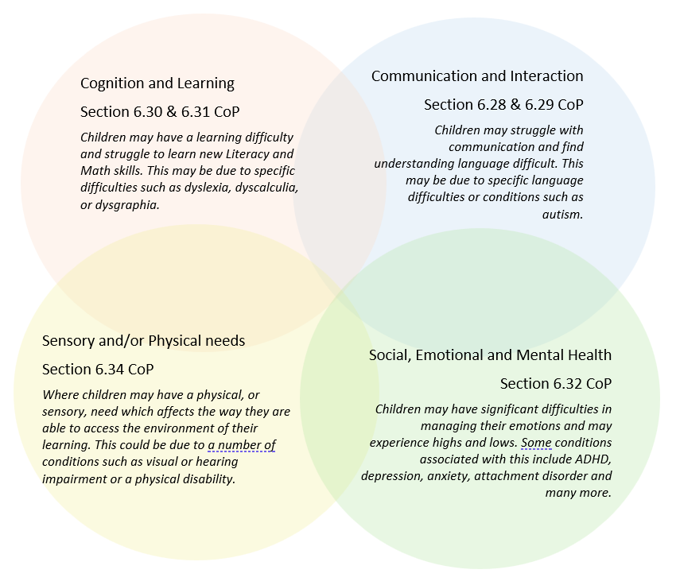

Often you will find that children’s needs overlap and are rarely confined to one area of need, which is why it is important to gain a wholistic overview of your child.
More information about the Areas of Need can be found in the Special educational needs and disability code of practice: 0 to 25 years (link below).
SEND_Code_of_Practice_January_2015.pdf (publishing.service.gov.uk)


2. Which staff will support my child, and what are their key responsibilities?

At Grove Park School all staff are considered responsible for supporting the needs of pupils with SEND. Our staff are committed to regular, high-quality training to ensure that they have the knowledge and skills to better meet a wide range of pupil needs.
Below outlines key staff who will be supporting your child. Please note that this list is not exhaustive.
Our Special Educational Needs Co-ordinator, or SENCO
The named SENCO is Amanda Harling
They have 16 years experience in this role and have worked as nursery, reception, year one, year two and year three teacher. They are a qualified teacher.
They achieved the National Award in Special Educational Needs Co-ordination in 2010.
They have had training in therapeutic supports such as drawing and talking and TAMs. They are an accredited Irlen screener, they can screen for dyslexia and they have a good knowledge of needs such as dyspraxia and sensory processing difficulties. They have received training from the Autistic Education Trust (AET). They regularly attend training to keep up to date with changes within the current SEND system.

Class/subject teachers
All of our teachers receive in-house SEN training, and are supported by the SENCO to meet the needs of pupils who have SEN.
All staff have regular training from outside professionals and inhouse.
We have focused on promoting Autism awareness, with particular attention to the classroom environment. Support has been provided through the Autism Education Trust, with staff completing the Making Sense of Autism training. In addition, some staff have enhanced their expertise further by completing Level 2 of the Good Autism Practice program.
All staff have undertaken training to adapt and adjust teaching approaches, ensuring that learning is accessible to all pupils. The Zones of Regulation program has also been implemented across all classrooms, following completion of staff training. Furthermore, we have supported staff in the effective use of technology to meet a wide range of learning needs.
We also have access to a trauma informed teacher to support individuals or groups of children.
Teaching assistants (TAs)
We have a team of 25 TAs, including 2 higher-level teaching assistants (HLTAs).
We have 2 additional teaching assistants who are trained to support children with bespoke interventions such as speech and language support and social emotional and mental health support.

In the last academic year, TAs have been trained in behaviour for learning, Autism awareness, EEF scaffolding learning and enabling learning environments, safeguarding, to name a few.
TA’s support interventions such as, Little Wandle catch up, Zones of regulation, Sensory circuits, clever fingers and other SEN programmes.

External agencies
Sometimes we need extra help to offer our pupils the support that they need. Whenever necessary we will work with external support services to meet the needs of our pupils with SEND and to support their families. These may include:
- SEND Inclusion Advisor
- Occupational Therapists
Child and adolescent mental health services (CAMHS)
- Education welfare officers
- Educational psychologists
- GPs or paediatricians
- NELFT practitioners
- Occupational therapists
- School Liaison Officer
- School nurses
- Specialist Teacher Service
- Play therapist
- Speech and language therapists

- Voluntary sector organisation
- Trauma informed teacher
- Therapeutic practitioners
- Safeguarding services

- 

3. What should I do if I think my child has SEND?

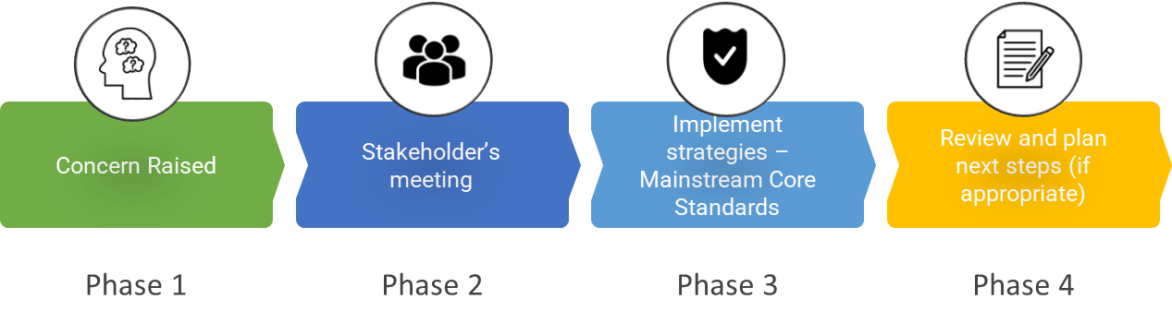

Phase 1 | If you think your child might have SEND, raise your concern with the school so that the SENCO is aware. Please contact the school office to request a meeting with class teacher and SENCo. (01795 477417 or email grovepark@ba-mat.org.uk  Please speak to your child’s class teacher in the first instance to help class team understand your concerns. They may at this point request support from the SENCO.
Phase 2 | We will meet with you to discuss your concerns and try to get a better understanding of what your child’s strengths and difficulties are. Together we will decide what outcomes to seek for your child and agree on next steps. We will make a note of what’s been discussed and add this to your child’s record.
Phase 3 | We will implement the agreed strategies and monitor these over an agreed period of time. These are likely to be universal strategies set out in the mainstream core standards. A copy of this can be found here: https://www.kelsi.org.uk/__data/assets/pdf_file/0005/117257/Special-educational-needs-mainstream-core-standards-guide-for-parents.pdf . This will initiate the ‘Graduated Approach’ where support will be continually reviewed. See next page for more details.
Phase 4 | If we decide that your child needs SEND support, we will formally notify you and your child will be added to the school’s SEND register. They will receive additional support through an ILP (Individualised Learning Plan) and this will be reviewed using the assess, plan, do, review model.

4. What happens if the school identifies a need?

We will assess each pupil’s current skills and levels of attainment on entry, which will build on previous settings and Key Stages, where appropriate. Class teachers will make regular assessments of progress for all pupils and identify those whose progress:
- Is significantly slower than that of their peers starting from the same baseline
- Fails to match or better the child’s previous rate of progress
- Fails to close the attainment gap between the child and their peers
- Widens the attainment gap
- This may include progress in areas other than attainment, for example, social and emotional needs.
Slow progress and low attainment will not automatically mean a pupil is recorded as having SEN. When deciding whether special educational provision is required, we will start with the desired outcomes, including the expected progress and attainment, and the views and the wishes of the pupil and their parents. We will use this to determine the support that is needed and whether we can provide it by adapting our core offer, or whether something different or additional is needed.
- Children with SEND will be identified as soon as is possible.
- Several assessment methods are used by Grove Park to accurately identify and assess pupils’ needs. Examples of these include reading speed tests, phonics assessments. However, the school often utilises services provided by outside agencies such as CAMHs, the Specialist teaching and learning service, speech and language therapist, occupational therapist and Early Help.
- We use screening tools such as NELI in year R, Irlen screening, Speech and Language Link screening, dyscalculia, dyslexia YARC (reading assessment) and phonics assessments etc
- We use observations and discussions with the child. The recommendations are shared with the class team and then a follow up observation may be conducted to ensure early impact is being seen
- According to their identified needs, children will be designated as needing:
  - SEND provision within school supported by a school Individual Learning Plan (ILP).
  - SEND provision supported by an Education, Health and Care (EHC) plan, drawn up by the local authority (LA) in liaison with local education, health care and social care providers who have contact with the family.
- The SEND register, which contains the names of all children with SEND, will be updated once a term.
- Children who need close monitoring, where their needs maybe under investigation or making slow progress with widening gaps will be added to the monitoring list. Children who have been identified/diagnosed with a difficulty but do not require support beyond quality first teaching are also added to the monitoring list.
- ILPs will be reviewed on a termly basis (3 times a year) by the SENCO and the class teacher and Parents and carers will be kept informed of progress being made as updated ILPs are sent home every term.
- EHCPs will be reviewed by the SENCO with teachers, parents and carers at parent's evenings and in the annual review which may involve outside agencies.
- Parents and carers will be kept informed.
- Clear and up-to-date records will be kept at every stage.
- The LA has the responsibility to make EHC assessments and draw up EHC plans.
- The LA must work within prescribed time limits to produce an EHC plan (a maximum of 20 weeks)
The same process is followed if a concern is raised by the school.

All our class teachers are responsible for the monitoring of all pupils who have been identified as having SEND. They also review those who are not making the expected level of progress in their schoolwork or socially. This might include reading, writing, math, social, and emotional development.
If the teacher notices that a pupil is having difficulties, they try to find out if the pupil has any gaps in their learning. If they can find a gap, the school will provide appropriate support. Pupils who don’t have SEND usually make progress quickly once the gap in their learning has been filled.

If the pupil is still finding it difficult to make the expected progress, the teacher will talk to the SENCO and will contact you to discuss the possibility that your child has SEND, and the school will follow the graduated approach (see previous page).

5. How will the school measure my child’s progress?
We will follow the graduated approach and the four-part cycle of assess, plan, do, review. The class teacher will work with the SENCO to carry out a clear analysis of the pupil’s needs.
Each pupil with SEND has their needs, targets and interventions detailed on an Individual Learning Plan (ILP) which are completed by the SENCO, class teacher and TA. The aim of this is to identify areas of strength and development as well as setting goals which can be from a pastoral or academic points of view. This information is then shared with parents/carers. ILPs are reviewed and updated 3 times per year.
This will draw on:
- There is a whole school data capture 3 times per year, with phonics assessments captured more frequently (6 weekly in KS1 and 3 weekly in KS2) to ensure that a ‘keep up not catch up’ approach can be implemented
- Pupil ILPs are reviewed informed by the school data capture, teacher and TA assessment and support from SENCo
- The teacher’s assessment and experience of the pupil regarding attitude, behaviour and attendance
- Their previous progress and attainment and behaviour
- The individual’s development in comparison to their peers and national data
- The views and experience of parents
- The pupil’s own views shared via their teacher and through discussions
- Advice from external support services, if relevant. For example, the Educational Psychology Team, the Specialist Teaching and Learning Service, Early Help or the Speech and Language Therapist
- Observations from baseline, with follow up to check for impact

The assessment will be reviewed regularly. All teachers and support staff who work with the pupil will be made aware of their needs, the outcomes sought, the support provided, and any teaching strategies or approaches that are required. We will regularly review the effectiveness of the support and interventions and their impact on the pupil’s progress.
Pupils with SEND have several opportunities to be involved in their education. They are encouraged to have an input into their statutory review meetings through identifying their strengths, areas for development and suggesting how improvements can be implemented. This can be from either a pastoral or academic point of view.
We will follow the ‘graduated approach’ to meeting your child’s SEND needs.

The graduated approach is a 4-part cycle of assess, plan, do, review.
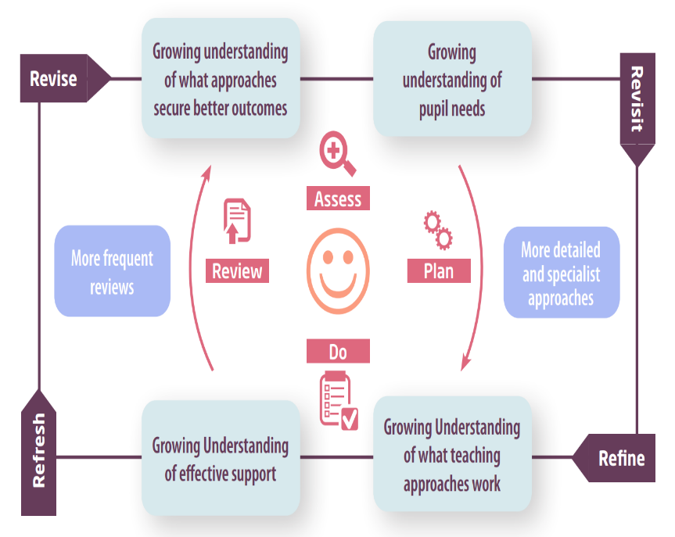

Assess | If your child is not making the expected level of progress, we will make an assessment to find out what strengths and difficulties your child has. We will ask for you and your child’s input, as well as getting help from external professionals where necessary.
Plan | In discussion with you and your child, we will decide what outcomes we are hoping to achieve. We will make a plan of the support we will offer your child to help them meet those outcomes. We will make a record of this and share it with you and all relevant school staff.
Do | We will put our plan into practice.  The class teacher, with the support of the SENCO, will be responsible for working with your child on a daily basis, and making sure the support we put in place is having the impact we intended.
Review | We will assess how well the support we put in place helped the pupil to meet the outcomes we set. We will use our improved understanding of your child’s needs to improve the support we offer; this may mean the Plan, Assess, Do, Review cycle continues.

6. How will I be involved in decisions made about my child’s education?
We will provide termly reports via your child’s ILP on their progress.

You will have opportunities to attend 2 parent/teacher meetings per year and if your child has an ILP 3 further meetings with the SENCO will be offered. Over and above this, children with an EHCP will have an annual review meeting. At these meetings we can discuss:
- Clear outcomes for your child’s progress
- Review progress towards those outcomes
- Discuss the support we will put in place to help your child make that progress
- Identify what we will do, what we will ask you to do, and what we will ask your child to do
- In year 6 we provide a robust transition, our FLO is available to support pupils by visiting their new schools during term 6.

We know that you’re the expert when it comes to your child’s needs and aspirations. So, we want to make sure you have a full understanding of how we’re trying to meet your child’s needs, so that you can provide insight into what you think would work best for your child.

We also want to hear from you as much as possible so that we can build a better picture of how the SEND support we are providing is impacting your child outside of school. If your child’s needs or aspirations change at any time, please let us know right away so we can keep our provision as relevant as possible.

If you have concerns that arise between these meetings, please contact the school office at grovepark@ba-mat.org.uk . An appointment can be made to get in touch with your child’s class teacher and/or SENCO to discuss any issues.

7. How will my child be involved in decisions made about their education?
The level of involvement will depend on your child’s age and individual needs. We recognise that no two pupils are the same, so we will decide on a case-by-case basis, with your input.

We may seek your child’s views by asking them to:
- Attend meetings to discuss their progress and outcomes
- Prepare a presentation, written statement, video, drawing, etc.
- Discuss their views with a member of staff who can act as a representative during the meeting
- Complete a survey


8. How will the school adapt its teaching for my child?
Your child’s teachers are responsible and accountable for the progress and development of all the pupils in their class.

High-quality teaching is our first step in responding to your child’s needs. We will make sure that your child has access to a broad and balanced curriculum in every year they are at our school.

We will adapt our approaches to how we teach to suit the way the pupil works best. There is no 'one size fits all’ approach to adapting the curriculum, we work on a case-by case basis to make sure the adaptations we make are meaningful to your child and are guided by the Mainstream Core Standards in the first instance.


These adaptations may include:

- Adapting our approaches, for example, giving longer processing times, pre-teaching of key vocabulary, reading instructions aloud, visual supports and symbols, task management boards etc.
- Adapting our resources and staffing

- Using recommended aids, such as laptops, coloured overlays, visual timetables, larger/different font, wobble cushions, sloping desks, weighted lap pads, fiddle toys, workstations and ear defenders etc.
- Teaching assistants, teachers or support staff will support pupils appropriately depending on their presentation of need

- Scaffolding lesson materials, providing manipulatives, simplified language, making tasks multisensory.

We may also provide the following interventions:
Speech and language interventions such as NELI (Reception) Language link, Speech Link, colourful semantics, Language for Behaviour and Emotions and Language for Thinking and star word

Learning interventions, such as Little Wandle SEN programme, pre teaching, Numicon, typingclub, clicker 8, Little Wandle catch up.
Physical and sensory interventions such as Sensory circuits, movement breaks, clever fingers, BEAM, doh disco,
Social, Emotional, mental health support- ELSA, TAMs (the amazing me programme) Hamish and Milo, soft starts, safe space, cuddle corner, play therapy, Talk time, Nurture4all and therapy dog.
These interventions are part of our contribution to Kent County Council’s local offer.
For further information regarding our accessibility plan please contact the school who will be happy to share the information with you.

9. How will the school evaluate whether the support in place is helping my child?
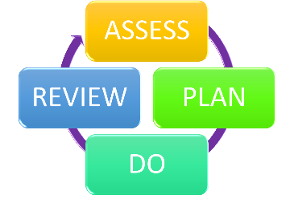
We will evaluate the effectiveness of provision for your child by:
- Reviewing their progress towards their goals each term
- Reviewing the impact of interventions after 6-8 weeks
- Using pupil questionnaires/voice
- Monitoring by the SENCO
- Holding an annual review (if they have an education, health and care (EHC) plan)
- Through ILP reviews and teacher assessments

10. How will the school ensure my child has appropriate resources?
At Grove Park we provide resources that are both bespoke and universal depending on a child’s presentational needs. Our funding supports staffing as well as different provisions such as forest school, rainbow room, individualised social emotional mental health support.
It may be that your child’s needs mean we need to provide additional resources such as:
- Additional resources to support their learning
- Adaptations to in class support
- Further training for our staff
- External specialist expertise
Where appropriate, we will consult with external agencies to get recommendations on what will best help your child access their learning and use our best endeavours to ensure these are supplied.

11. How will the school make sure my child is included in activities alongside pupils who don’t have SEND?


The expectation is that all schools providing an inclusive provision for all pupils. It may be necessary for some pupils to receive interventions in addition to a broad and balanced curriculum.
All of our extra-curricular activities and school visits are available to all our pupils, including our before and after-school clubs.
All pupils are encouraged to go on our school trips.
All pupils are encouraged to take part in sports days, school plays, special events, school discos, Forest school.
No pupil is ever excluded from taking part in these activities because of their SEN or disability and we will make whatever reasonable adjustments are needed to make sure that they can be included.

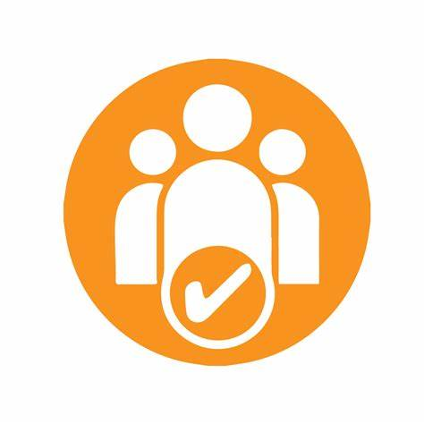
12. How does the school make sure the admissions process is fair for pupils with SEN or a disability?
- Admissions are dealt with under the Kent County Council admissions process. Kent County Council has a Fair Access Protocol (FAP) as required by the School Admission code. This sets out the following criteria for an in year fair access referral which can be found on
- https://www.kelsi.org.uk/admissions/in-year-fair-access-protocol
- Grove Park strives to be a fully inclusive school. All children are welcome, including those with additional educational needs, in accordance with the LA admissions’ policy.
- If a parent wishes to have their child with an Education and Healthcare Plan educated in the mainstream, the LA must provide a place, unless incompatible with the efficient education of other children; and there are no reasonable steps that can be taken to prevent the incompatibility.
- Before admission, parents, carers and children visit the school and they are encouraged to voice any concerns they might have about their child’s integration into school.
- Our current admissions form requests that parents or carers state any special needs that their child has.
Here is the link to the 2025 admissions policy download.asp (bourne-alliance-mat.org.uk)

13. How does the school support pupils with disabilities?


At Grove Park our school site offers all pupils access regardless of disability.
You’re disabled under the Equality Act 2010 if you have a physical or mental impairment that has a ‘substantial’ and ‘long-term’ negative effect on your ability to do normal daily activities.

14. How will the school support my child’s mental health and emotional and social development?
We provide support for pupils to progress in their emotional and social development in the following ways:
- Pupils with SEND are encouraged to be part of the school council
- Pupils with SEND are also encouraged to be part of all clubs offered to promote teamwork/building friendships
- We provide extra pastoral support for listening to the views of pupils with SEND by sessions in the “Rainbow Room”
- We run a Zen Den for pupils who need extra support with social or emotional development at Lunch times
- Talk time counselling provided by an external service provider
- Play therapy
- Trauma informed teacher is available to support Individual's and classes.
- Our Family liaison Officer, Mrs Cornell, is the pupil wellbeing lead.
- We provide Nurture sessions and interventions such as ELSA, TAMs
- We have a ‘zero tolerance’ approach to bullying. At Grove Park we enable all children to be happy and safe, through a positive culture and vales. download.asp (bourne-alliance-mat.org.uk)

15. What support is in place for looked-after and previously looked-after children with SEND?


Amanda Harling our SENCO will make sure that all teachers understand how a looked-after or previously looked-after pupil’s circumstances and their SEND might interact, and what the implications are for teaching and learning.
Pupils who are looked-after or previously looked-after will be supported much in the same way as any other child who has SEND. However, looked-after pupils will also have a personal education plan (PEP). We will make sure that the PEP and any SEND support plans or EHC plans are consistent and complement one another.

16. What support will be available for my child as they transition between classes or settings or in preparing for adulthood?
Between years

To help pupils with SEND be prepared for a new school year we:
- Ask both the current teacher and the next year’s teacher to attend final meetings of the year when the pupil’s SEND is discussed
- Schedule lessons with the incoming teacher towards the end of the summer term
- Provide a transition booklet for the child to support them through the process.
Between schools
When your child is moving on from our school, we will ask you and your child what information you want us to share with the new setting.
Between phases
The SENCO of the secondary school will meet with our SENCO. They will discuss the needs of all the pupils who are receiving SEND support. A staff member from the secondary school will arrange to discuss the needs of all children transferring to their setting with the Year 6 class teachers. The children’s school file, SEND file (and safeguarding file if appropriate) will be sent on to the secondary setting.
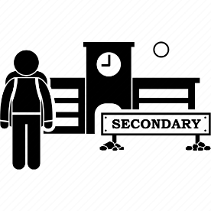
Pupils will be prepared for the transition by:
- Learning how to get organised independently
- Plugging any gaps in knowledge

17. What support is available for me and my family?
If you have questions about SEND, or are struggling to cope, please get in touch to let us know. We want to support you, your child and your family.
To see what support is available to you locally, have a look at Kents local offer. Kent County Council publishes information about the local offer on their website:
About the special educational needs and disabilities (SEND) local offer - Kent County Council
Our local special educational needs and disabilities information advice and support services (SENDIASS) organisations are:
Home | IASK
Local charities that offer information and support to families of pupils with SEND are:
Home | adhd-sheppey
Autism Apprentice | The Autism Apprentice CIC
We Are Beams | Supporting Disabled Children and Young People
National charities that offer information and support to families of pupils with SEND are:
- IPSEA
- SEND family support
- NSPCC
- Family Action
- Special Needs Jungle

18. What should I do if I have a complaint about my child’s SEND support?
The difference between a concern and a complaint
• A concern may be defined as ‘an expression of worry or doubt over an issue considered to be important for which reassurances are sought’.
• A complaint may be defined as ‘an expression of dissatisfaction however made, about actions taken or a lack of action’
It is in everyone’s interest that concerns and complaints are resolved at the earliest possible stage. Many issues can be resolved informally, without the need to use the formal stages of the complaints procedure.
How to raise a concern or make a complaint: A concern or complaint can be made in person by parents, carers (including parents or carers of children no longer at the school) and members of the public, in writing, in person or by telephone. They may also be made by a third party acting on behalf of a complainant, as long as they have appropriate consent to do so.
Concerns should be raised with the class teacher in the first instance. The class teacher will meet to address and resolve the concern. We may offer informal mediation at this stage. While this can be useful in helping the school and complainants reach an agreement and move forward, there are times when it may not be the most appropriate course of action. We will ask the parents/carers what they think may resolve the issue.
Complaints against school staff (except the Head of School or CEO) should be made in the first instance to the Head of School via the school office. If written, then please mark them as Private and Confidential.
If you are not satisfied with the school’s response, you can escalate the complaint.
To see a full explanation of suitable avenues for complaint, see pages 246 and 247 of the SEND Code of Practice.
If you feel that our school discriminated against your child because of their SEND, you have the right to make a discrimination claim to the first-tier SEND tribunal. To find out how to make such a claim, you should visit: https://www.gov.uk/complain-about-school/disability-discrimination
You can make a claim about alleged discrimination regarding:
- Admission
- Exclusion
- Provision of education and associated services
- Making reasonable adjustments, including the provision of auxiliary aids and services
Before going to a SEND tribunal, you can go through processes called disagreement resolution or mediation, where you try to resolve your disagreement before it reaches the tribunal.
- Mediation and Resolution - KELSI

19. Supporting documents

- Equality Information and Objectives Policy
- Child protection and safeguarding policy
- Behaviour Policy
- Accessibility Plan
- Attendance and punctuality policy
- SEND policy
- SEN & Disabilities Code Of Practice 2015
- Mainstream Core Standards

20. Glossary
- Access arrangements – special arrangements to allow pupils with SEND to access assessments or exams
- Annual review – an annual meeting to review the provision in a pupil’s EHC plan
- Area of need – the 4 areas of need describe different types of needs a pupil with SEND can have. The 4 areas are communication and interaction; cognition and learning; physical and/or sensory; and social, emotional and mental health needs.
- CAMHS – child and adolescent mental health services
- Differentiation – when teachers adapt how they teach in response to a pupil’s needs
- EHC needs assessment – the needs assessment is the first step on the way to securing an EHC plan. The local authority will do an assessment to decide whether a child needs an EHC plan.
- EHC plan – an education, health and care plan is a legally-binding document that sets out a child’s needs and the provision that will be put in place to meet their needs.
- First-tier tribunal/SEND tribunal – a court where you can appeal against the local authority’s decisions about EHC needs assessments or plans and against discrimination by a school or local authority due to SEND
- Graduated approach – an approach to providing SEND support in which the school provides support in successive cycles of assessing the pupil’s needs, planning the provision, implementing the plan, and reviewing the impact of the action on the pupil
- Intervention – a short-term, targeted approach to teaching a pupil with a specific outcome in mind
- Local offer – information provided by the local authority which explains what services and support are on offer for pupils with SEND in the local area
- Outcome – target for improvement for pupils with SEND. These targets don't necessarily have to be related to academic attainment
- Reasonable adjustments – changes that the school must make to remove or reduce any disadvantages caused by a child’s disability
- SENCO – the special educational needs co-ordinator
- SEN – special educational needs
- SEND – special educational needs and disabilities
- SEND Code of Practice – the statutory guidance that schools must follow to support pupils with SEND
- SEND information report – a report that schools must publish on their website, that explains how the school supports pupils with SEND
- SEND support – special educational provision which meets the needs of pupils with SEND
- Transition – when a pupil moves between years, phases, schools or institutions or life stages

