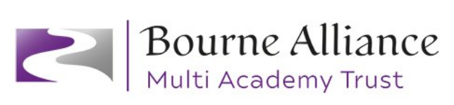

Policy Document for: Relationship and Sex Education (RSE)
Due for Review: March 2026
This policy is written using Relationships and sex education (RSE) and health education - GOV.UK (www.gov.uk) and Introduction to requirements - GOV.UK (www.gov.uk)

Ethos and rationale
At Bourne Academy Trust, Relationship and Sex Education (RSE) gives children the essential skills for building positive and respectful relationships and equips them to stay safe on and offline. It teaches children how to be happy, healthy and confident individuals and grow into responsible citizens. RSE is learning accurate and age-appropriate skills, attitudes and knowledge about the body, reproduction, sex and sexual health. Some aspects of RSE are taught through Science and others are taught as part of personal, social, health and economic education (PSHE).

RSE is not about the promotion of sexual activity.

Aims
The aims of RSE at our school are to:
- Provide a framework in which sensitive discussions can take place
- Prepare pupils for puberty, and give them an understanding of sexual development and the importance of health and hygiene
- Help pupils develop feelings of self-respect, confidence and empathy
- Create a positive culture around issues of sexuality and relationships
- Teach pupils the correct vocabulary to describe themselves and their bodies.

We ensure RSE is inclusive and meets the needs of all our pupils including those with special educational needs and disabilities (SEND). Teachers ensure that the content, approach and the use of inclusive language reflect the diversity of the school community and help all pupils feel values and included regardless of their gender, ability, experiences and family background.

Statutory requirements
Relationship and Health Education has been statutory in primary schools since September 2020. Academy Trusts are not required to follow the National Curriculum and may choose not to teach the elements of sex education in the science curriculum where there is a reason not to do so. However, at Bourne Academy Trust we have chosen to teach the elements of sex education contained in the science curriculum as part of the National Curriculum.
The Trust will have regard to guidance issued by the secretary of state as outlined in section 403 of the Education Act 1996 as well as being in line with our funding agreement and articles of association.

Legislation
From September 2020 the Department for Education introduced compulsory Relationship Education and Health Education for all pupils receiving primary education.

Sex Education is not compulsory in primary schools, for aspects which are not part of the Science curriculum (conception and birth).

Policy development
- Review – a working party reviewed relevant information and national and local guidance materials to ensure compliance
- Staff consultation – all school staff were given the opportunity to review a draft document and make recommendations
- Parent/Stakeholder consultation – parents and any interested parties were invited to review the draft policy before ratification
- Pupil consultation – all pupils were consulted through work done in class with their class teacher, feedback shared with the PSHE Lead
- Ratification – once amendments were made the policy was shared with the Trust Board and ratified

Curriculum Design
We use Kapow’s scheme of work and supplement this following consultation with parents, pupils and staff taking into account the needs and feelings of pupils. If pupils ask questions outside the scope of our curriculum, teachers will respond in an appropriate manner, so pupils are fully informed and don’t seek answers online.

Our RSE programme is an integral part of our whole school personal, social, health and economic (PSHE) education curriculum. Our whole school PSHE curriculum, incorporating RSE, can be found on the website.

RSE is taught within the personal, social, health and economic (PSHE) education curriculum. Biological aspects of RSE are taught within the science curriculum, and other aspects are included in religious education (RE).

Relationships Education focuses on teaching the fundamental building blocks and characteristics of positive relationships including
- Families and Relationships
- Health and Wellbeing
- Safety and the Changing body
- Citizenship
- Economic Wellbeing

Across all Key Stages pupils will be supported with developing the following skills:
- Communication, including how to manage changing relationships and emotions
- Recognising and assessing risks
- Assertiveness
- Seeking help and support when required
- Informed decision making
- Self-respect and empathy for others
- Recognising and maximising a healthy lifestyle
- Managing conflict
- Discussion and group work

These skills are taught within the context of family life taking care to ensure that there is no stigmatism of children based on their home circumstances, along with reflecting sensitively that some children may have a different structure of support around them. We are aware that we have a number of same-sex families, adopted children, foster families, blended families, single parents and children who live with grandparents or wider family.

Lessons will be delivered in a variety of ways including circle time, hot seating, whole class and small group discussions and use various resources such as books and film clips. Pupils also receive stand-alone sex education sessions delivered by their class teacher and/or a trained health professional when required. Lessons may be graduated and age appropriate, particularly for SEND children where a small group or one to one discussion where more appropriate.

The transition phase before moving to Secondary school must support pupils ongoing emotional and physical development effectively. The Department for Education recommends that all Primary schools have a sex education programme which is tailored to the age and physical and emotional maturity of our pupils and ensures that both boys and girls and prepared for the changes that adolescence brings, drawing on the National curriculum elements of the human life cycle which are part of Science. The Trust ensures that teaching and materials are appropriate to the age and stage of development of the pupils in year 6, as well as those with SEND who may have different stages of development and/or learning barriers. Year 6 teachers are happy to offer support to parents about how to have discussions about sex education at home, and how this links to the programme in school.

RSE will be assessed through ipsative assessment. The children will be asked to complete a baseline assessment to gauge their prior knowledge and understanding of a topic. Then, after a series of lessons, they shall be invited to reflect on their previous knowledge to measure their progression within a topic.

At the end of the academic year each year group will review the RSE programme they have implemented and pass on comments to the PSHE Lead as part of the monitoring cycle. The Senior Leadership Team shall also meet with the PSHE/RSE Lead to discuss contextual influences and how the curriculum may need to be adjusted to meet these.

SEND pupils
The RSE curriculum must be accessible to all pupils. This is particularly important when planning for teaching our pupils with SEND to ensure that this is personalised to their starting points and appropriate to their age and stage of development.

The Trust is aware that some pupils are more vulnerable to exploitation, bullying and other issues due to the nature of their SEND. Relationships Education and RSE can also be particularly important subjects for some pupils; for example, those with Social, Emotional and Mental Health needs or learning disabilities. These factors are taken into consideration in designing and teaching these subjects.

LGBTQ
In teaching Relationships Education and RSE, we will ensure that the needs of all pupils are appropriately met, and that all pupils understand the importance of equality and respect. We will ensure that we comply with the relevant provisions of the Equality Act 2010 and The Equality Act 2010: advice for schools, under which sexual orientation and gender reassignment are amongst the protected characteristics.
The curriculum covers LGBTQ+ through relationships education in a way that is sensitive and age appropriate in approach and content using materials from ‘Kapow’ and ‘No Outsiders’. Examples of ‘No Outsiders’ lessons are detailed below along with the picture books used. The context of our pupils makes this a relevant area to cover at Primary since we have pupils in key stage 2 who are questioning their gender in addition to pupils with same sex families, who are part of our school community. This is not delivered through standalone lessons, but fully integrated into the programme of study and represented in the resources that we use in lesson delivery and displays in our schools.
The currant draft guidance states
- ‘Schools can most commonly refer to families with a mother and a father when discussing families, but should be sensitive to pupils’ circumstances, recognising that some children may have a different structure of support around them. For example, looked after children or young carers. Families of many forms provide a nurturing environment for children, and can include single parent families, same-sex parents, families headed by grandparents, kinship carers, adoptive parents and foster parents/carers. Care should be taken to ensure that children are not stigmatised based on their home circumstances and needs.’
- ‘We expect the majority of primary schools to teach about healthy loving relationships. Primary schools have discretion over whether to discuss sexual orientation or families with same-sex parents.’

Equality
All schools are required to comply with relevant requirements of the Equality Act 2010. Further guidance is available for schools in https://www.gov.uk/guidance/equality-act-2010-guidance and https://www.gov.uk/government/publications/equality-act-2010-advice-for-schools . Schools should pay particular attention to the Public sector equality duty (PSED) (s.149 of the Equality Act).

Under the provisions of the Equality Act, schools must not unlawfully discriminate against pupils because of their age, sex, race, disability, religion or belief, gender reassignment, pregnancy or maternity, marriage or civil partnership, or sexual orientation (collectively known as the protected characteristics). Schools must also make reasonable adjustments to alleviate disadvantage and be mindful of the SEND Code of Practice when planning for these subjects.

Provisions within the Equality Act allow schools to take positive action, where it can be shown that it is proportionate, to deal with particular disadvantages affecting one group because of a protected characteristic. This should be taken into consideration in designing and teaching these subjects. A school, could, for example, consider taking positive action to support girls if there was evidence that they were being disproportionately subjected to sexual violence or sexual harassment. This will be monitored as the curriculum is delivered, alongside ongoing reviews of incidents for safeguarding, behaviour and wellbeing on CPOMS system by the Assistant Head Teachers and Strat Team. Any patterns which emerge will be identified and positive action taken to make adjustments in the curriculum or any additional action which needs to be taken.

The contextual makeup of the pupils, including gender balance and any pupils with particular protected characteristics are considered in developing our RSE and PSHE curriculum. The Trust is ambitious for all pupils and acts positive to create an environment which challenges perceived limits on pupils based on their gender or any other characteristic, including through these subjects and as part of a whole-school approach. The Trust is mindful of issues such as everyday sexism, misogyny, homophobia and gender stereotypes and takes positive action to build a culture where these are not tolerated, and any occurrences are identified and tackled. Staff have an important role to play in modelling positive behaviours. The Trust policies are developed to support all pupils, such as safeguarding and child protection and behaviour policies.

Ongoing CPD as part of our safeguarding culture continues to support staff awareness of these issues. An understanding for all pupils of healthy relationships, acceptable behaviour and the right of everyone to equal treatment will help ensure that pupils treat each other well and go on to be respectful and kind adults.

Roles and Responsibilities

The Governing Body
- The Governing Body has delegated the approval of this policy to the CEO
- Acts to hold the Heads of School to account for the implementation of this policy
- Undertakes monitoring of the impact of the curriculum
- Ensures that clear information is provided for parents on the subject content and the right to request that their child is withdrawn

The Inclusion and Well-being Lead and the PSHE Lead
The Leads are responsible to ensure the RSE curriculum content meets the needs of the children and the requirements of the Department for Education.

The Head of School
The Head of School is responsible for ensuring the RSE is taught consistently across their school, and for managing requests to withdraw pupils form the non-statutory components of RSE.

Teaching Staff
Staff are responsible for:
- Delivering RSE in a sensitive way
- Modelling positive attitudes to RSE
- Monitoring progress
- Responding to the needs of individual pupils
- Responding appropriately to pupils whose parents wish them to be withdrawn from the non-statutory components of RSE so that meaningful learning activities are provided

Pupils
- Pupils are expected to engage fully in RSE and, when discussing issues related to RSE, treat others with respect and sensitivity. Teachers and pupils will agree ground rules at the beginning of the work, in addition to those already embedded by our behaviour policy and classroom rules.

Staff training
Staff are trained on the delivery of RSE as part of our CPD calendar across the year, as well as where teachers may need support and training in answering questions which are best not dealt with in front of a whole class.

The Head of School will coordinate with the PSHE/RSE Lead to invite visitors from outside the school, such as school nurses to provide support and training to staff teaching RSE.

Monitoring of effectiveness of the RSE curriculum
The delivery of the RSE curriculum is monitored by the PSHE/RSE Curriculum Lead and the designated staff members locate at each mainstream school. Pupil development in RSE is assessed by class teachers as part of their usual internal assessment processes.

Safeguarding
Teachers are aware that effective RSE, which brings an understanding of what is and what is not appropriate in a relationship, can lead to a disclosure of a child protection issue. In this instance the teacher will consult with the Designated Safeguarding Lead (DSL) and ensure the relevant safeguarding procedure is logged and updated in a timely manner alerting the DSL team and assigned to the Head of School.

The Trust makes use of agencies such as NSPCC who deliver relationships education which is appropriate for the different key stages in Primary school.

Visitors and external agencies who support the delivery of RSE will be required to read the RSE policy in advance to ensure they are informed of the safeguarding protocols and are supportive of the school’s whole school approach to RSE.

Pupils will be taught how to report concerns and get help when they think something is wrong, both in their online life as well as in ‘real’ life. This knowledge helps to support safeguarding children.

Working with parents
The role of our parents and carers in the development of their children’s understanding about relationships is vital since they have the most significant influence in enabling their children to grow and mature and form healthy relationships.

The Trust works closely with parents and carers in planning and delivering the RSE curriculum through consulting on the proposed curriculum and ensuring parents know what is taught and when.

Withdrawing your child
Parents do not have the right to withdraw their children from Relationship Education as from September 2020 as this became a compulsory element of RSE.

Parents have the right to withdraw their children from the non-statutory components of RSE; that being sex education beyond the biological and reproductive aspects required of the science curriculum (conception and birth).

Requests for withdrawal should be put in writing and addressed to the Head of School - a copy of the withdrawal request shall be placed in the pupil’s educational record. The Head of School will discuss the request with the parents the benefits of receiving this important education and any detrimental effects that withdrawal might have on the child. This could include any social and emotional effects of being excluded, as well as the likelihood of the child hearing their peers’ version of what was said in the classes, rather than what was directly said by the teacher. Although the detrimental effects may be mitigated if the parents propose to deliver sex education to their child at home instead.

This process is the same for pupils with SEND – there may be exceptional circumstances which the Head of School will consider in discussion with the child’s parents.

After discussions with parents, the parents still wish to withdraw their child, this will be granted from sex education, other than part of the science curriculum.

The teachers will then provide purposeful, appropriate education for any child withdrawn. There is no right to withdraw from Relationships Education or Health Education.

No Outsiders
“No Outsiders in our school. Everyone is different and everyone is welcome.” This scheme helps children to explore that everyone has the right to their views and beliefs and that these need to be respected through storybooks.
EYFS | No Outsiders Lesson 1 - To choose what I like  Story ‘You choose’ by Nick Sharratt  No Outsiders Lesson 2 - Its ok to be different  Story ‘Red rockets and rainbow jelly’ by Sue Heap and Nick Sharrat | No Outsiders Lesson 3 - To say hello  Story ‘Hello hello’ by Brendan Wenzel  No Outsiders Lesson 4 - All families are different  Story ‘The family book’ by Todd Parr | No Outsiders Lesson 5 - To celebrate my family  Story ‘Mommy, Mama and me’ by Leslea Newman and Carol Thompson  No Outsiders Lesson 6 - To make a new friend  Story ‘Blue Chameleon’ by Emily Gravett
YEAR 1 | No Outsiders Lesson 1 – I like the way I am  Story ‘Elmer’ by David Mckee  No Outsiders Lesson 2 - To join in  Story ‘Going to the volcano’ by Andy Stanton | No Outsiders Lesson 3 - To find ways to play together  Story ‘Want to play trucks?’ by Ann Stott and Bob Graham  No Outsiders Lesson 4 - Proud to be me  Story ‘Hair, it’s a family affair’ by Mylo Freeman | No Outsiders 5 - I share the world with lots of people  Story ‘My world, your world’ by Melanie Walsh  No Outsiders 6 - To work together  Story ‘ Errol’s garden’ by Gillian Hibbs
YEAR 2 | No Outsiders Lesson 1 - To welcome different people  Story ‘Can I join your club?’ by John Kelly and Steph Laberis  No Outsiders Lesson 2 - To have self confidence  Story ‘ How to be a lion’ by Ed Vere | No Outsiders Lesson 3 - To understand what diversity means  Story ‘The great big book of families’ by Mary Hoffman and Ros Aquith  No Outsiders Lesson 4 - To think about what makes a good friend  Story ‘Amazing’ by Steve Antony | No Outsiders Lesson 5 - To communicate in different ways  Story ‘What the jackdaw saw’ by Julia Donaldson and Nick Sharrat  No Outsiders Lesson 6 - To know I belong  Story ‘All are welcome’ by Alexandra Penfold and Suzanne Kaufman
YEAR 3 | No Outsiders Lesson 1 - To understand what discrimination means  Story ‘This is our house’ by Michael Rosen  No Outsiders Lesson 2 - To understand what a bystander is  Story ‘We’re all wonders’ by RJ Palacio | No Outsiders Lesson 3 - To be welcoming  Story ‘Beegu’ by Alexis Deacon  No Outsiders Lesson 4 - To recognise a stereotype  Story ‘The truth about old people’ by Elina Ellis | No Outsiders Lesson 5 - To recognise and help an outsider  Story ‘The hueys in a new jumper’ by Oliver Jeffers  No Outsiders Lesson 6 - To consider living in Britain today  Story ‘Planet Omar’ by Zanib Mian
YEAR 4 | No Outsiders Lesson 1 - To help someone accept difference  Story ‘Along came a different’ by Tom McLaughlin  No Outsiders Lesson 2 - To choose when to be assertive  Story ‘Dongs don’t do ballet’ by Anna Kemp and Sarah Oglivie | No Outsiders Lesson 4.3 To be proud of who I am  Story ‘Red – A crayons story’ by Michael Hall  No Outsiders Lesson 4.4 - To find common ground  Story ‘Aalfred and Aalbert’ by Morag Hood | No Outsiders Lesson 4.5 - To look after my mental health  Story ‘When sadness comes’ by Eva Eland  No Outsiders Lesson 4.6 - To show acceptance  Story ‘Julian is a mermaid’ by Jessica Love
YEAR 5 | No Outsiders Lesson 1 - To consider consequences  Story ‘Kenny lives with Erica and Martina’ by Ollie Pike  No Outsiders Lesson 2 - To justify my actions  Story ‘Rose Blanche’ by Ian McEwan and Roberto Innocenti | No Outsiders Lesson 3 - To consider responses to racist behaviour  Story ‘Mixed’ by Arree Chung  No Outsiders Lesson 4 - To recognise when someone needs help  Story ‘How to heal a broken wing’ by Bob Graham | No Outsiders Lesson 5 - To explore friendship  Story ‘The girls’ by Lauren Lee and Jenny Lovlie  No Outsiders Lesson 6 - To exchange dialogue and express an opinion  Story ‘And tango makes three’ by Justin Richardson and Peter Parnell
YEAR 6 | No Outsiders Lesson 1 - To consider responses to immigration  Story ‘King of the sky’ by Nicola Davis  No Outsiders Lesson 2 - To consider language and freedom of speech  Story ‘The only way is badger’ by Stella J Jones | No Outsiders Lesson 3 - To overcome fears about difference  Story ‘Leaf’ by Sandra Dieckmann  No Outsiders Lesson 4 - To consider causes of racism  Story ‘The island’ by Armin Greder | No Outsiders Lesson 6 - To consider democracy  Story ‘A day in the life of Marlon Bundo’ by Marlon Bundo and Jill Twiss
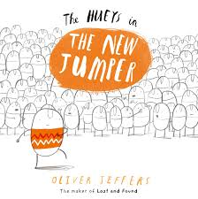
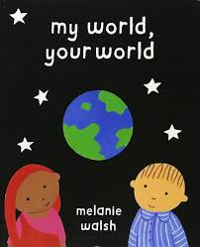
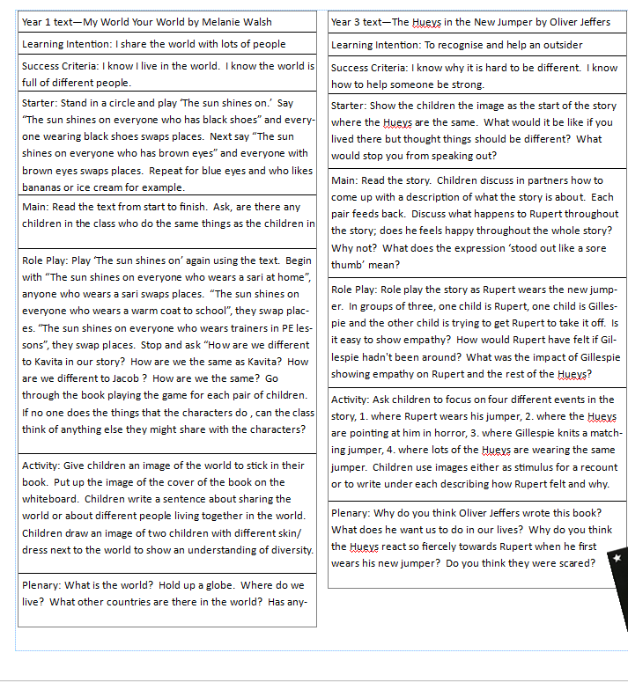
No Outsiders example lesson plans and stories.

